**Final Report**

1. Project Name

Book Local, Sleep Easy

1. ER Diagram

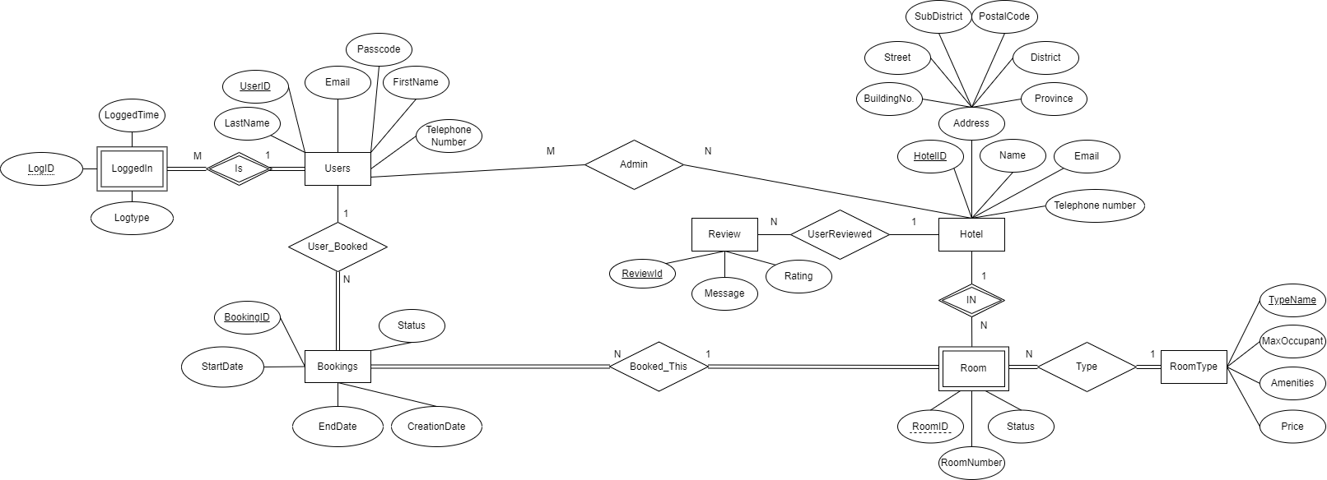

1. Schema Diagram

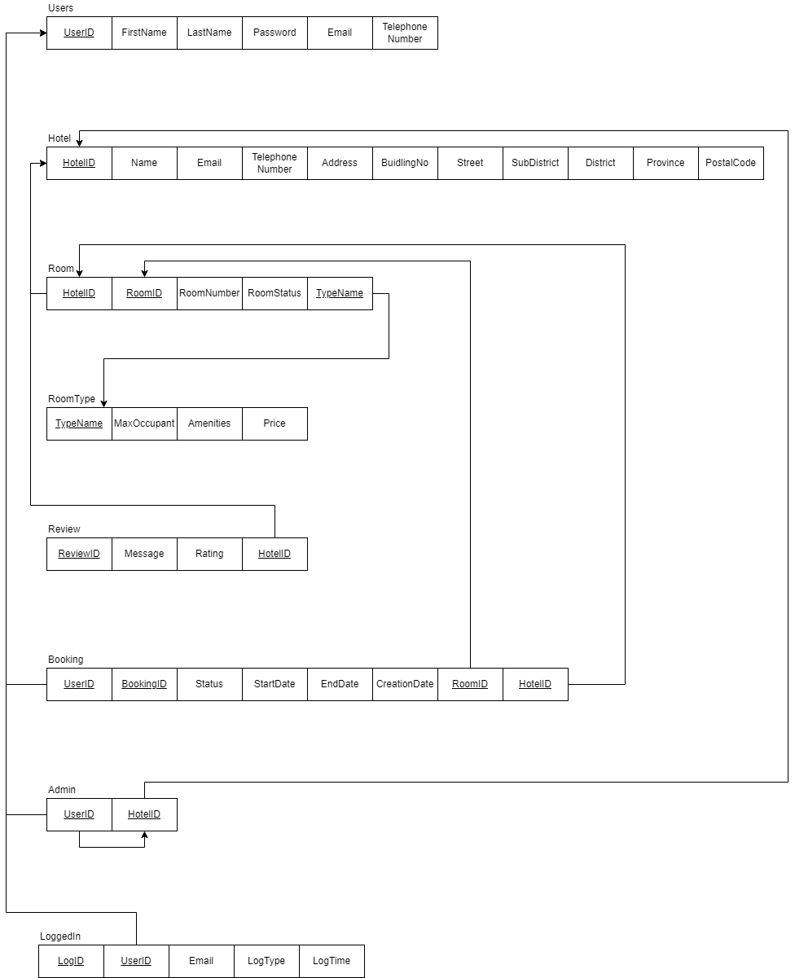

1. SQL Commands
2. The system shall allow a user to register by specifying the name, telephone number, email, and password.

CREATE OR REPLACE FUNCTION add_user (

    firstname VARCHAR(255),

    lastname VARCHAR(255),

    emaill VARCHAR(255),

    passcode VARCHAR(255),

    telephoneNumber VARCHAR(10))

    RETURNS BOOLEAN

    LANGUAGE plpgsql

    AS

$$

DECLARE

    checkemail VARCHAR(255);

    rn INTEGER;

BEGIN

    SELECT users.email

    INTO checkemail

    FROM users

    WHERE emaill = users.email;

    IF FOUND THEN

        RETURN FALSE;

    END IF;

    INSERT INTO users VALUES

    (DEFAULT, firstname, lastname, emaill, passcode, telephoneNumber);

    RETURN TRUE;

END;

$$

|  |  |  |  |  |  |
| --- | --- | --- | --- | --- | --- |
| "userid" | "firstname" | "lastname" | "email" | "passcode" | "telephonenumber" |
| 1 | "John" | "Doe" | "john.doe@example.com" | "password123" | "1234567890" |
| … |  |  |  |  |  |
| 6 | "John" | "Doe" | "alice.j@example.com" | "password123" | "1234567890" |

1. After registration, the user becomes a registered user, and the system shall allow the user to log in to use the system by specifying the email and password. The system shall allow a registered user to log out.

CREATE OR REPLACE FUNCTION log_in(

    emaill VARCHAR,

    passcodee VARCHAR)

    RETURNS BOOLEAN

    LANGUAGE plpgsql

    AS

$$

DECLARE

    realpasscode VARCHAR(255);

    realuserID INTEGER;

BEGIN

    SELECT u.passcode, u.userID

    INTO realpasscode,realuserID

    FROM users u

    WHERE u.email = emaill;

    IF NOT FOUND THEN

        RETURN FALSE;

    ELSE

        IF realpasscode = passcodee THEN

            INSERT INTO loggedin VALUES (DEFAULT, realuserID, emaill,'login', now());

            RETURN TRUE;

        ELSE

            RETURN FALSE;

        END IF;

    END IF;

END;

$$

CREATE OR REPLACE PROCEDURE log_out(

    emaill VARCHAR

    )

    LANGUAGE plpgsql

    AS

$$

DECLARE

    realuserID INTEGER;

BEGIN

    SELECT u.userID

    INTO realuserID

    FROM users u

    WHERE u.email = emaill;

    INSERT INTO loggedin VALUES (DEFAULT, realuserID, emaill,'logout', now());

    COMMIT;

END;

$$

|  |  |  |  |  |
| --- | --- | --- | --- | --- |
| "logid" | "userid" | "email" | "logtype" | "loggedtime" |
| 1 | 1 | "john.doe@example.com" | "login" | "2024-02-07 07:07:50.973113" |
| 2 | 1 | "john.doe@example.com" | "logout" | "2024-02-07 07:08:16.829738" |

1. After login, the system shall allow the registered user to book up to 3 nights by specifying the date and the preferred hotel. The hotel list is also provided to the user. A hotel information includes the hotel name, address, and telephone number.

--Checking if the date specified is <= 3 nights.

CREATE OR REPLACE FUNCTION hotel_list(

    in_startDate DATE,

    in_endDate DATE)

RETURNS TABLE(

    HotelName VARCHAR,

    RoomType VARCHAR,

    buildingNo VARCHAR,

    street VARCHAR,

    subDistrictName VARCHAR,

    districtName VARCHAR,

    province VARCHAR,

    postalCode VARCHAR,

    email VARCHAR

)

LANGUAGE plpgsql

AS $$

BEGIN

    IF (in_endDate - in_startDate) <= 4 THEN

        RETURN QUERY

        SELECT h.name,

               rt.typeName,

               h.buildingNo,

               h.street,

               h.subDistrictName,

               h.districtName,

               h.province,

               h.postalCode,

               h.email

        FROM room R

        JOIN Hotel h ON R.hotelId = h.hotelId

        JOIN RoomType rt ON R.typeName = rt.typeName

        WHERE NOT EXISTS (

            SELECT 1

            FROM Booking b

            WHERE R.roomId = b.roomId

              AND h.hotelId = b.hotelId

              AND ((in_startDate BETWEEN b.startDate AND b.endDate) OR (in_endDate BETWEEN b.startDate AND b.endDate))

        );

    ELSE

        RETURN NEXT;

    END IF;

END;

$$;

-- Book Hotel

CREATE OR REPLACE FUNCTION booking_hotel(

    in_startDate DATE,

    in_enddate DATE,

    hotel_id INTEGER,

    room_id INTEGER,

    user_Id INTEGER

)

RETURNS BOOLEAN

LANGUAGE plpgsql

AS $$

BEGIN

    INSERT INTO booking VALUES(user_Id, DEFAULT, 1,in_startdate, in_enddate, NOW(), room_id, hotel_id);

    RETURN TRUE;

END $$

|  |  |  |  |  |  |  |  |
| --- | --- | --- | --- | --- | --- | --- | --- |
| "userid" | "bookingid" | "bookingstatus" | "startdate" | "enddate" | "creation_date" | "roomid" | "hotelid" |
| 1 | 1 | "1" | "2024-02-01" | "2024-02-05" | "2024-01-15 10:00:00" | 1 | 1 |
| … |  |  |  |  |  |  |  |
| 1 | 6 | "1" | "2023-02-01" | "2023-02-02" | "2024-02-07 07:10:27.561318" | 1 | 1 |

1. The system shall allow the registered user to view his hotel bookings.

CREATE OR REPLACE FUNCTION view_hotel_bookings(

    Inuserid INTEGER

)

RETURNS TABLE(

    bookingID INTEGER,

    bookingStatus VARCHAR,

    startDate DATE,

    endDate DATE,

    RoomType VARCHAR,

    Hotelname VARCHAR

    )

LANGUAGE plpgsql

AS $$

BEGIN

RETURN QUERY

SELECT DISTINCT B.bookingID, B.bookingStatus, B.startDate, B.endDate, R.typeName, H.name

FROM Booking B, users U, Room R, Hotel H

WHERE B.userID = Inuserid and  B.roomID = R.roomID and H.hotelID = B.hotelID;

END;

$$

|  |  |  |  |  |  |
| --- | --- | --- | --- | --- | --- |
| "bookingid" | "bookingstatus" | "startdate" | "enddate" | "roomtype" | "hotelname" |
| 6 | "1" | "2023-02-01" | "2023-02-02" | "Standard" | "Luxury Hotel" |
| 1 | "1" | "2024-02-01" | "2024-02-05" | "Standard" | "Luxury Hotel" |

1. The system shall allow the registered user to edit his hotel bookings.

CREATE OR REPLACE PROCEDURE edit_hotel_bookings(

    booking_ID INTEGER,

    booking_status VARCHAR,

    start_date DATE,

    end_date DATE,

    creationdate TIMESTAMP,

    room_id INTEGER,

    hotel_id INTEGER

)

    LANGUAGE plpgsql

    AS

$$

DECLARE

    realhotelID INTEGER;

BEGIN

    UPDATE booking SET bookingStatus = booking_status,

                        startdate = start_date,

                        enddate = end_date,

                        creation_date = NOW(),

                        roomid = room_id,

                        hotelid = hotel_id

        WHERE bookingID = booking_ID;

        RETURN;

END;

$$

|  |  |  |  |  |  |  |  |
| --- | --- | --- | --- | --- | --- | --- | --- |
| "userid" | "bookingid" | "bookingstatus" | "startdate" | "enddate" | "creation_date" | "roomid" | "hotelid" |
| 2 | 2 | "1" | "2024-03-01" | "2024-03-10" | "2024-02-01 12:30:00" | 3 | 2 |
| … |  |  |  |  |  |  |  |
| 1 | 1 | "2" | "2024-03-01" | "2024-03-10" | "2024-02-07 07:13:42.264409" | 2 | 1 |

1. The system shall allow the registered user to delete his hotel bookings.

CREATE OR REPLACE PROCEDURE delete_hotel_bookings(

    userID INTEGER, booking_ID INTEGER

)

LANGUAGE plpgsql

AS $$

BEGIN

    DELETE FROM booking B where booking_ID = B.bookingID;

END;

$$

|  |  |  |  |  |  |  |  |
| --- | --- | --- | --- | --- | --- | --- | --- |
| "userid" | "bookingid" | "bookingstatus" | "startdate" | "enddate" | "creation_date" | "roomid" | "hotelid" |
| 2 | 2 | "1" | "2024-03-01" | "2024-03-10" | "2024-02-01 12:30:00" | 3 | 2 |
| … |  |  |  |  |  |  |  |
| 1 | 6 | "1" | "2023-02-01" | "2023-02-02" | "2024-02-07 07:10:27.561318" | 1 | 1 |

1. The system shall allow the admin to view any hotel bookings.

CREATE OR REPLACE FUNCTION admin_view_booking(

    Inuserid INTEGER

)

RETURNS TABLE(

    bookingID INTEGER,

    firstname VARCHAR,

    lastname VARCHAR,

    bookingStatus VARCHAR,

    startDate DATE,

    endDate DATE,

    RoomType VARCHAR

    )

LANGUAGE plpgsql

AS $$

DECLARE

    userhotelID INTEGER;

BEGIN

SELECT A.hotelID

INTO userhotelID

FROM Admin A

WHERE InuserID = A.UserID;

IF NOT FOUND THEN

    RETURN NEXT;

END IF;

RETURN QUERY

SELECT DISTINCT B.bookingID, U.firstname, U.lastname, B.bookingStatus, B.startDate, B.endDate, R.typeName

FROM Booking B, users U, Room R

WHERE B.userID = U.userID and B.hotelID = userhotelID and B.roomID = R.roomID;

END;

$$

|  |  |  |  |  |  |  |
| --- | --- | --- | --- | --- | --- | --- |
| "bookingid" | "firstname" | "lastname" | "bookingstatus" | "startdate" | "enddate" | "roomtype" |
| 2 | "Jane" | "Smith" | "1" | "2024-03-01" | "2024-03-10" | "Deluxe" |

1. The system shall allow the admin to edit any hotel bookings.

CREATE OR REPLACE PROCEDURE admin_edit_booking(

    booking_ID INTEGER,

    booking_Status VARCHAR,

    start_date DATE,

    end_date DATE,

    creationdate TIMESTAMP,

    room_id INTEGER,

    edituser INTEGER

)

    LANGUAGE plpgsql

    AS

$$

DECLARE

    realhotelID INTEGER;

BEGIN

    SELECT Admin.hotelID

    INTO realhotelID

    FROM Admin

    WHERE Admin.userID = edituser;

    IF NOT FOUND THEN

        RETURN;

    ELSE

        UPDATE booking set bookingStatus = booking_Status,

                            startdate = start_date,

                            enddate = end_date,

                            creation_date = NOW(),

                            roomid = room_id

        where bookingID = booking_ID;

        RETURN;

    END IF;

END;

$$

|  |  |  |  |  |  |  |  |
| --- | --- | --- | --- | --- | --- | --- | --- |
| "userid" | "bookingid" | "bookingstatus" | "startdate" | "enddate" | "creation_date" | "roomid" | "hotelid" |
| 3 | 3 | "1" | "2024-04-15" | "2024-04-20" | "2024-03-01 08:45:00" | 5 | 3 |
| … |  |  |  |  |  |  |  |
| 2 | 2 | "2" | "2024-03-01" | "2024-03-10" | "2024-02-07 07:17:28.3894" | 4 | 2 |

1. The system shall allow the admin to delete any hotel bookings.

CREATE OR REPLACE PROCEDURE admin_delete_booking(

    adminuserID INTEGER,

    deletebookingID INTEGER

)

    LANGUAGE plpgsql

    AS

$$

DECLARE

    adminId INTEGER;

BEGIN

    SELECT admin.userId

    INTO adminId

    FROM admin

    WHERE admin.userId = adminuserId;

    IF NOT FOUND THEN

        RETURN;

    ELSE

        DELETE FROM booking WHERE booking.bookingId = deletebookingID;

        RETURN;

    END IF;

END;

$$

|  |  |  |  |  |  |  |  |
| --- | --- | --- | --- | --- | --- | --- | --- |
| "userid" | "bookingid" | "bookingstatus" | "startdate" | "enddate" | "creation_date" | "roomid" | "hotelid" |
| 3 | 3 | "1" | "2024-04-15" | "2024-04-20" | "2024-03-01 08:45:00" | 5 | 3 |
| … |  |  |  |  |  |  |  |
| 1 | 6 | "1" | "2023-02-01" | "2023-02-02" | "2024-02-07 07:10:27.561318" | 1 | 1 |

1. Complex Query

แสดง ราคาเฉลี่ยของ hotel ที่อยู่ในจังหวัด กรุงเทพ ที่มี rating มากกว่า 4.0 มา 3 อันดับแรก โดยเรียงจากมากไปน้อย โดยนำข้อมูล rating จาก Review ที่มี hotelId ตรงกับ hotelId ที่ต้องการหา

SELECT h.name AS HotelName, ROUND(AVG(rt.price),2) AS AveragePrice

FROM Hotel h

JOIN Room ro ON h.hotelId = ro.hotelId

JOIN Review re ON h.hotelId = re.hotelId

JOIN RoomType rt ON ro.typeName = rt.typeName

WHERE h.province = 'Bangkok' AND re.rating > 4.0

GROUP BY h.hotelId, h.name

ORDER BY AVG(rt.price) DESC

LIMIT 3;

|  |  |
| --- | --- |
| "hotelname" | "averageprice" |
| "Cozy Inn" | "200.00" |
| "Luxury Hotel" | "150.00" |
| "Mountain Lodge" | "125.00" |

1. Document-based Design Schema

{

"User": {

"properties": {

"_id": { "bsonType": "objectId" },

"firstName": { "bsonType": "string" },

"lastName": { "bsonType": "string" },

"email": { "bsonType": "string", "unique": true },

"passcode": { "bsonType": "string" },

"telephoneNumber": { "bsonType": "string", "pattern": "/^[0-9]{10}$/" },

"isAdmin": { "bsonType": "bool" }

},

"required": ["_id", "firstName", "lastName", "email", "passcode", "telephoneNumber", "isAdmin"]

},

"Admin": {

"properties": {

"_id": { "bsonType": "objectId" },

"userId": { "bsonType": "objectId" },

"hotelId": { "bsonType": "objectId" }

},

"required": ["_id", "userId", "hotelId"],

},

"Hotel": {

"properties": {

"_id": { "bsonType": "objectId" },

"name": { "bsonType": "string" },

"telephoneNumber": { "bsonType": "string", "pattern": "/^[0-9]{10}$/" },

"email": { "bsonType": "string" },

"buildingNo": { "bsonType": "string" },

"street": { "bsonType": "string" },

"subDistrictName": { "bsonType": "string" },

"districtName": { "bsonType": "string" },

"province": { "bsonType": "string" },

"postalCode": { "bsonType": "string", "pattern": "/^[0-9]{5}$/" },

"rooms": {

"bsonType": "array",

"items": {

"bsonType": "object",

"properties": {

"_id": { "bsonType": "objectId" },

"roomNumber": { "bsonType": "int" },

"status": { "bsonType": "string" },

"type": { "bsonType": "string" }

},

"required": ["_id", "roomNumber", "status", "type"]

}

}

},

"required": ["_id", "name", "telephoneNumber", "buildingNo", "subDistrictName", "districtName", "province", "postalCode"]

},

"RoomType": {

"properties": {

"_id": { "bsonType": "objectId" },

"typeName": { "bsonType": "string" },

"maxOccupant": { "bsonType": "int" },

"amenities": { "bsonType": "string" },

"price": { "bsonType": "int" }

},

"required": ["_id", "typeName", "maxOccupant", "amenities", "price"]

},

"Booking": {

"properties": {

"_id": { "bsonType": "objectId" },

"bookingStatus": { "bsonType": "string", "enum": ["pending", "confirmed", "cancelled"] },

"startDate": { "bsonType": "date" },

"endDate": { "bsonType": "date" },

"creation_Date": { "bsonType": "date" },

"user": { "bsonType": "objectId" },

"hotel": { "bsonType": "objectId" },

"room": { "bsonType": "objectId" }

},

"required": ["_id", "bookingStatus", "startDate", "endDate", "creation_Date", "user", "hotel", "room"]

},

"loggedin": {

"properties": {

"_id": { "bsonType": "objectId" },

"userId": { "bsonType": "objectId" },

"email": { "bsonType": "string" },

"logType": { "bsonType": "string", "enum": ["login", "logout"] },

"loggedTime": { "bsonType": "date" }

},

"required": ["_id", "userId", "email", "logType", "loggedTime"]

}

}